(1)tracefile:tr-simpleloop.ref

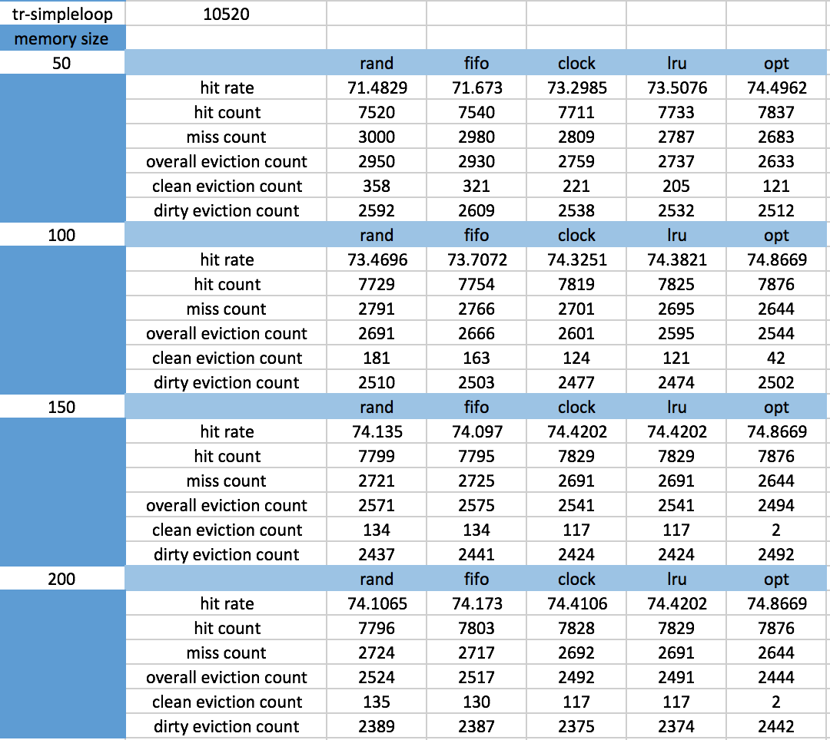

(2)tracefile:tr-matmul.ref

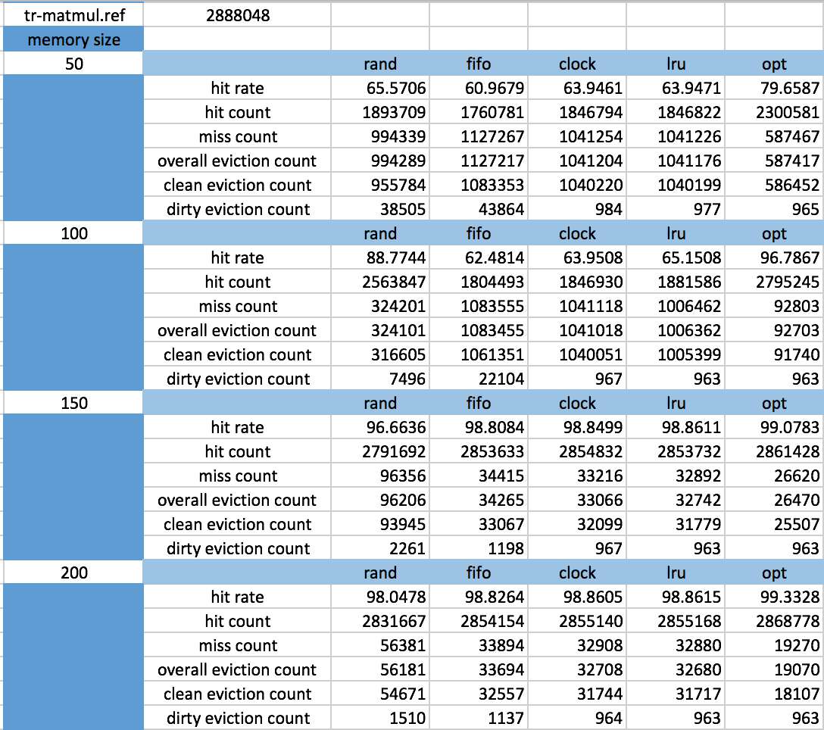

(3)tracefile:tr-blocked.ref

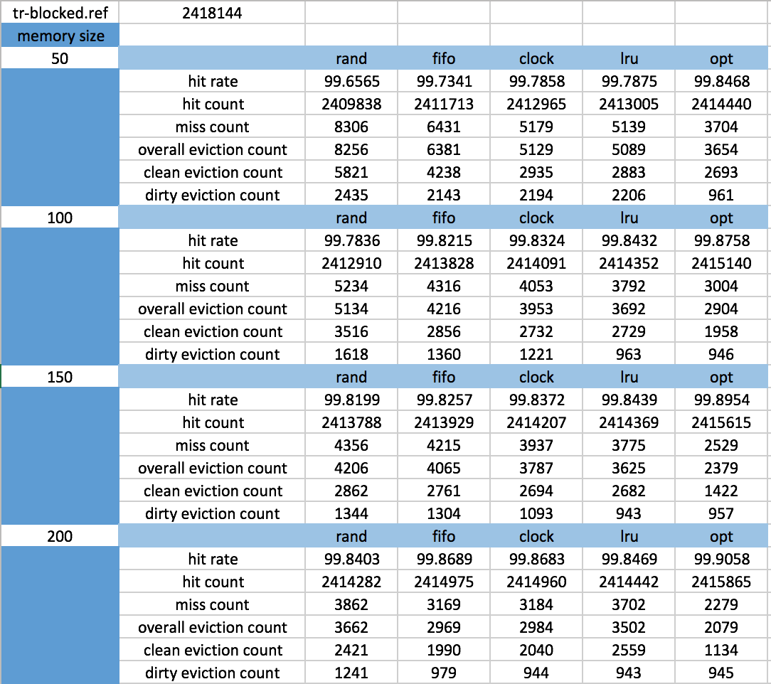

(4)tracefile:tr-mine.ref

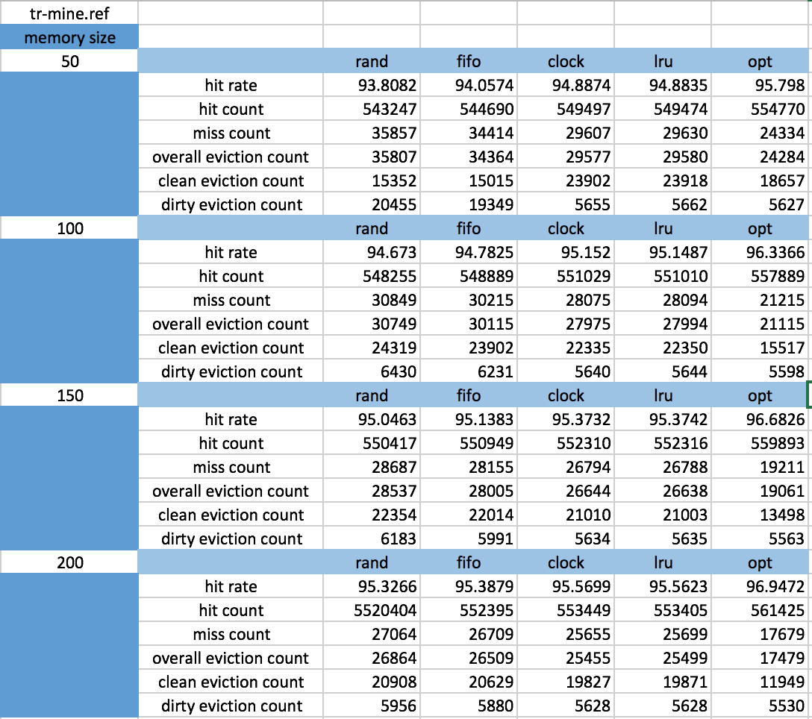

As can be seen from the charts. OPT has the best performance of course. Generally speaking the performance of lru ranked the second. In addition, clock performs a little better than fifo in most of the situation.

For lru, the performance of it increases as the size of the memory increases. That is to say that lru dosen’t suffers from Belady’s anomaly.